**Abstract**

The Cellular Automata Theory is a distinct model that is currently being utilized in scientific researches and simulations. The model is comprised of some cells that changes in accordance with a particular rule over time. This paper provides a survey of the Modeling and Applications of Cellular Automata Theory, that targets the program realization of Cellular Automata Theory and therefore the application of Cellular Automata in every field, like road traffic, land use, and cutting machines. every application is further explained, and a number of other are related to main models are concisely introduced. This research aims to assist decision-makers formulate applicable development plans.

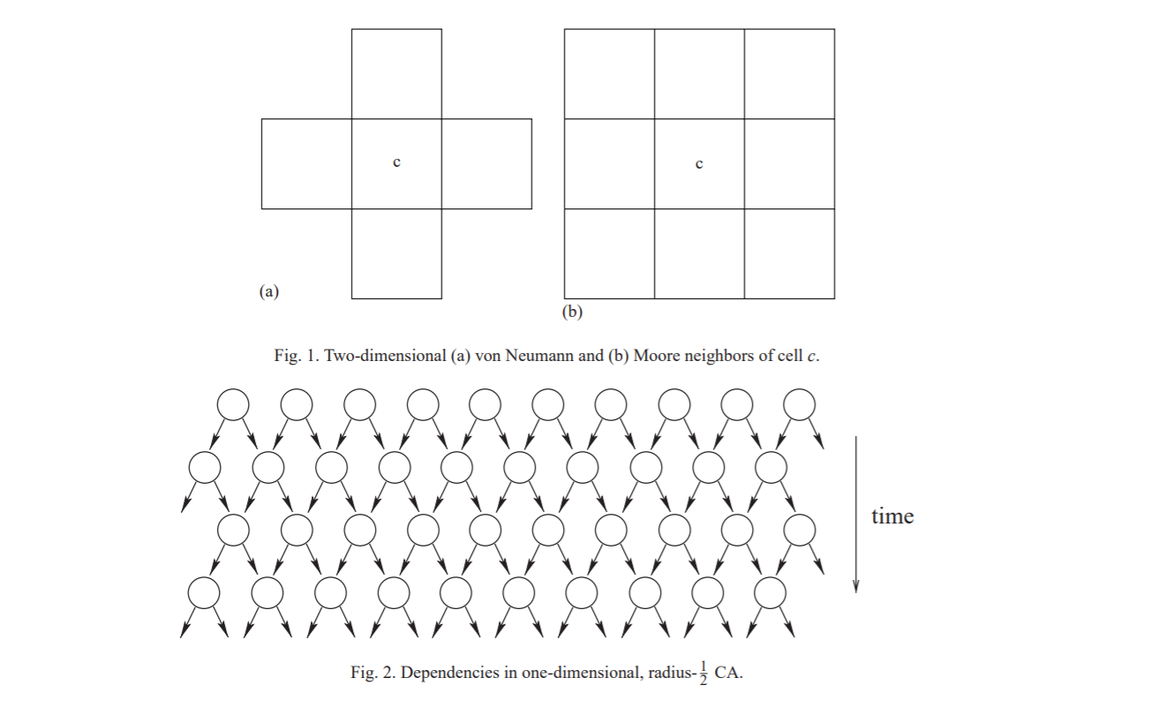

**Introduction**

Cellular automata (CA) are among the oldest models of natural computing, qualitative analysis back over half a century. the initial CA studies by John Neumann during the late Nineteen Forties were biologically intended, the goal was to develop self-replicating artificial systems that are also computationally universal.

Neumann clearly wanted to analyse artificial computing devices analogous to human brain in which the memory and the process units aren't separated from one another, that are massively parallel which is capable of repairing and building themselves given the required material.

Following suggestions by S. Ulam, he visualised a separate universe consisting of a two-dimensional mesh of finite state machines, known as cells, interconnected regionally with one another. The cells bring changes to their states synchronously reckoning on the states of some close cells, the neighbors, as determined by an area update rule. All cells use identical update rule so the system is homogeneous like several physical and biological systems. These cellular universes are currently known as CA. Von Neumann’s line of analysis on self-replicating CA was continued later by different authors.

CA possess many elementary properties of the physical world:they are massively

parallel, homogeneous each and every interactions are native. different physical properties like reversibility and conservation laws are often programmed by selecting the native update rule

properly. it's not shocking that physical and biological systems are successfully simulated with CA models . separate simulation of fluid flows using CA as even become a field of its own during which CA models are referred to as lattice gases. See, for example, for 2 elementary lattice gas models. different classic CA simulations of physical systems embrace Ising spin models and diffusion phenomena, e.g.

The physical nature of CA might have even a lot of larger sensible importance once applied

to the other direction, that is, once using the physics to simulate CA. Since several CA are

computationally universal—and some are simple and easy CA have this property—then maybe we tend to eventually succeed to harness physical reactions of microscopic scale to execute massively parallel computations by running a computationally universal CA. this needs that the simulated CA obeys the foundations of physics, together with reversibility and conservation laws.

While such truly programmable matter could also be decades away, its potential is nice

In this tutorial article, we tend to review basic theoretical results regarding CA in computer

science. the sector is incredibly broad and also the analysis is spirited, therefore it's solely attainable to hide bound

aspects of the sector. the chosen topics replicate the analysis interests of the author, and they

include changeability, conservation laws, decidability queries, machine catholicity

and limit behavior. For different topics see, for instance, books . we tend to begin by

defining basic ideas.

**Examples and Experimental Results:**

The structure of cellular automata is that the transmission of a single native node to a different one. Thus, any transmission drawback, social or else, are often sculpturesque with a cellular structure with applicable transmission dynamics’.

Yu Xiaoyang, Song Yang, Yu Shuchun, Yu Yang, Cheng Hao, Guan Yanxia in their research paper have described the usage of Cellular Automata in the encryption of QR code. In that paper, he wrote that the the performance of the security and integrity of QR code,i.e, Quick Response Code can be increased by encryption and cryptography supported cellular automata. In order to achieve this feat, encryption technique is used along with cryptography methodology supported elementary cellular automata stage rings was planned during that paper. The cellular automata will stimulate the complex phenomenon for which the cellular automata is being developed by just using a dynamic system. Based upon this feature, the aim of this technique is to employ cellular automata to encode and decode the binary images of the QR code with parameters like length, the cyclic bpundary conditions and the state space of {0,1} as QR code can be considered as an image consisting of only black and white pixels so representing the entire QR code image as a square matrix with only 0 and 1 being the elements representing black and white respectively.

Experimental results of the method given in that paper shows that the new method is much more faster, with good effect and with high security. The key of the of the encrypted image is very sensitive and even a small deviation in the key creates a drastic effect in the decryption of the image. It was also noticed that the correlation between the various adjacent pixels in all directions like vertical, horizontal and diagonal was much higher in the plain image and much lower in the ciphered encrypted image. This ensured that the adjacent pixels in the encrypted image are almost irrelevant, as the correlation coefficient in the encrypted image is very close to zero. It means that the statistical features and the original plain image without encryption are spread well enough in the decrypted ciphered image and hence we can conclude that the encryption with the key can create a unique encryption which ensures the primary condition for cryptography,i.e, one to one correspondence. Coming to the most important aspect, i.e, speed test, experimental results have shown that the time taken in the encryption of a encryption techniques like DES is roughly three times the time taken in the encryption by use of cellular automata. Similarly the decryption time of a encryption by use of DES is roughly four times than that of Cellular automata technique. Also since the key space of a cellular automata is quite large, cellular automata can resist the attack of key effectively.

In the Finite State Machine design procedure based on D1*C1 Cellular Automata, the state itself are encoded by means of an encoding module. Post encoding, we optimize the combinational logic of this Finite State Machine using MISII.

**Challenges:**

Experimental arithmetic provides a primary approach to the present downside. One performs  
explicit simulations of cellular automata, and tries to seek out empirical rules for his or her  
behaviour. These could then recommend results which will be investigated by a lot of standard mathematical ways.

Use of the finite information density of cellular automaton configurations, and the  
finite rate of information propagation in cellular automata, variety of inequalities  
may be derived between entropies and Lyapunov exponents .

Several straightforward observations could also be created. First, if the cellular automaton lattice is over one-dimensional, one could contemplate Lyapunov exponents in numerous  
directions on this lattice.

Random sampling yields some empirical indications of the frequencies of various  
classes of behaviour among cellular automaton rules of assorted sorts. For centrosymmetric  
one-dimensional cellular automata, category one and a pair of cellular automata seem to become progressively less common as k and r increase; category three becomes a lot of common,and class four slowly becomes less common.

**Future Opportunities:**

Modern urban traffic:

In this we tend to introduce a replacement cellular automata approach to construct AN urban traffic quality model. supported the developed model,characteristics of worldwide traffic patterns in urban areas area unit studied. Our results show that totally different control mechanisms used at intersections like cycle length, inexperienced split, and coordination of traffic lights have a big impact on bury vehicle spacing distribution and traffic dynamics.These findings give vital insights into the network property behaviour of urban traffic,which area unit essential for planning applicable routing protocols for transport impromptu networks in urban eventualities.

Seed encoding with LFSRs and cellular automata:

Reseeding is employed to enhance fault coverage of pseudo-random testing. The seed corresponds to the initial state of the PRPG before filling the scan chain. During this paper,we gift a method for cryptography a given seed by the quantity of clock cycles that the PRPG must run to succeed in it. This cryptography needs several fewer bits than the bits of the seed itself. The price is that the time to succeed in the supposed seed. We have a tendency to cut back this value mistreatment the degrees of freedom (due to do not cares in check patterns) in determination the equations for the seeds. We have a tendency to show results for implementing our technique utterly in on-chip hardware and for applying it from a tester. Simulations show that with low hardware overhead, the technique provides 100% single-stuck fault coverage. Also, when put next with typical reseeding from associate external tester or on-chip memory board, the technique reduces seed storage by up to eighty fifth. We have a tendency to show the way to apply the technique for each LFSRs and CA.

References:

* Sarkar, P. (2000). A brief history of cellular automata. Acm Computing Surveys, 32(1), 80-107.
* T. Ceccherini-Silberstein, M. Coornaert, Cellular automata and groups, Springer Monographs in Mathematics, Springer-Verlag, Berlin (2010).
* E.R. Berlekamp, J.H. Conway, R.K. Guy, Winning Ways for Your Mathematical Plays, Academic Press (1982).
* M. Margenstern, on a characterization of cellular automata in tilings of the hyperbolic plane, Internat. J. Found. Comput. Sci. 19 (2008), no. 5, 1235–1257.
* J. Kari, Theory of cellular automata: A survey, Theoretical Computer Science 334 (2005), 3–33.
* Shun Wai Tsang, Yee Leung. A Theory-Based Cellular Automata for the Simulation of Land-Use Change. Geographical Analysis 43(2011), no. 2, 142-171.
* Xianjuan Kong. Research on Modelling and Characteristics Analysis of Traffic Flow Based on Cellular Automaton. Beijing Jiaotong University, 2007.
* Xingqin Cao. The Cellular Automata Studying of Complex System. Huazhong University of Science and Technology, 2006.
* Xia Li, Jiaan Ye. Neural network based cellular automata and simulating complex land use system. Geography Research (2005), no. 24, 19-27.
* Wolfram, Stephen. A New Kind of Science. Champaign, IL: Wolfram Media Inc., 2002.
* Davis, Martin. The Universal Computer: The Road from Leibniz to Turing. New York: Norton, 2000.
* J. Albert, K. Culik II, A simple universal cellular automaton and its one-way and totalistic version, Complex Systems 1 (1987) 1–16.
* S. Amoroso, Y. Patt, Decision procedures for surjectivity and injectivity of parallel maps for tessellation structures, J. Comput. System Sci. 6 (1972) 448–464.
* H. Aso, N. Honda, Dynamical characteristics of linear cellular automata, J. Comput. System Sci. 30 (1985) 291–317.
* C. Bennett, Logical reversibility of computation, IBM J. Res. Develop. 6 (1973) 525–532.
* R. Berger, The undecidability of the Domino problem, Mem. Amer. Math. Soc. 66 (1966).
* E.R. Berlekamp, J.H. Conway, R.K. Guy, Winning Ways for Your Mathematical Plays II, Academic Press, New York, 1982.
* F. Blanchard, A. Maass, Dynamical properties of expansive one-sided cellular automata, Israel J. Math. 99 (1997) 149–174.
* N. Boccara, H. Fuks, Number conserving cellular automaton rules, Fund. Inform. 52 (2002) 1–13.
* T. Boykett, C. Moore, Conserved quantities in one-dimensional cellular automata, unpublished manuscript, 1998. 32 J. Kari / Theoretical Computer Science 334 (2005) 3 – 33
* A.W. Burks, Von Neumann’s self-reproducing automata, in:A.W. Burks (Ed.), Essays on Cellular Automata, University of Illinois Press, Champaign, IL, 1970, pp. 3–64.
* G. Cattaneo, E. Formenti, G. Manzini, L. Margara, Ergodicity, transitivity, and regularity for linear cellular automata over Zm, Theoret. Comput. Sci. 233 (2000) 147–164.
* C. Choffrut, K. Culik II, On real-time cellular automata and trellis automata, Acta Inform. 21 (1984) 393–409.
* B. Chopart, M. Droz, Cellular Automata Modeling of Physical Systems, Cambridge University Press, Cambridge, 1998.
* E.F. Codd, Cellular Automata, Academic Press, New York, 1968.
* J.H. Conway, unpublished, 1970.
* K. Culik II, An aperiodic set of 13 Wang tiles, Discrete Math. 160 (1996) 245–251.
* K. Culik II, S. Yu, Undecidability of CA classification schemes, Complex Systems 2 (1988) 177–190.
* K. Culik II, L.P. Hurd, S. Yu, Formal languages and global cellular automaton behavior, Physica D 45 (1990) 396–403.
* K. Culik II, J. Pachl, S. Yu, On the limit sets of cellular automata, SIAM J. Comput. 18 (1989) 831–842.
* E. Czeizler, J. Kari, A tight linear bound on the neighborhood of inverse cellular automata, to appear.
* R.L. Devaney, An introduction to chaotic dynamical systems, Addison–Wesley, Reading, MA, 1989.
* B. Durand, Global properties of 2D cellular automata, in:E. Goles, S. Martinez (Eds.), Cellular Automata and Complex Systems, Kluwer, Dordrecht, 1998, .
* B. Durand, E. Formenti, G.Varouchas, On undecidability of equicontinuity classification for cellular automata, in:M. Morvan, E. Remila (Eds.), Discrete Mathematics and Theoretical Computer Science Proceedings AB, 2003, pp. 117–128.
* J. Durand-Lose, Representing reversible cellular automata with reversible block cellular automata, in:R. Cori, J. Mazoyer, M. Morvan, R. Mosery (Eds.), Discrete Models Combinatorics Computation and Geometry, Springer, Berlin, 2001, pp. 145–154.